**Water Service Line Survey**

(Community name) utilities team is working to complete a service line survey in accordance with the EPA mapping mandate. This means that as homeowners, we are encouraging you to complete a survey about the water line coming into your home from the water main. Please use the provided resources to complete the survey. Thank you for your time and cooperation!

Add community logo here

Questions? Contact: (Community Contact & Phone Number)

Email: (Email Address)



**Service Line Self Survey**

**Scan the code below to watch a tutorial video!**

Items needed to perform

a scratch test:

* A qr code with black squares

  Description automatically generatedKey, screwdriver, or

penny

* Magnet
* Photos of scratched

area including the

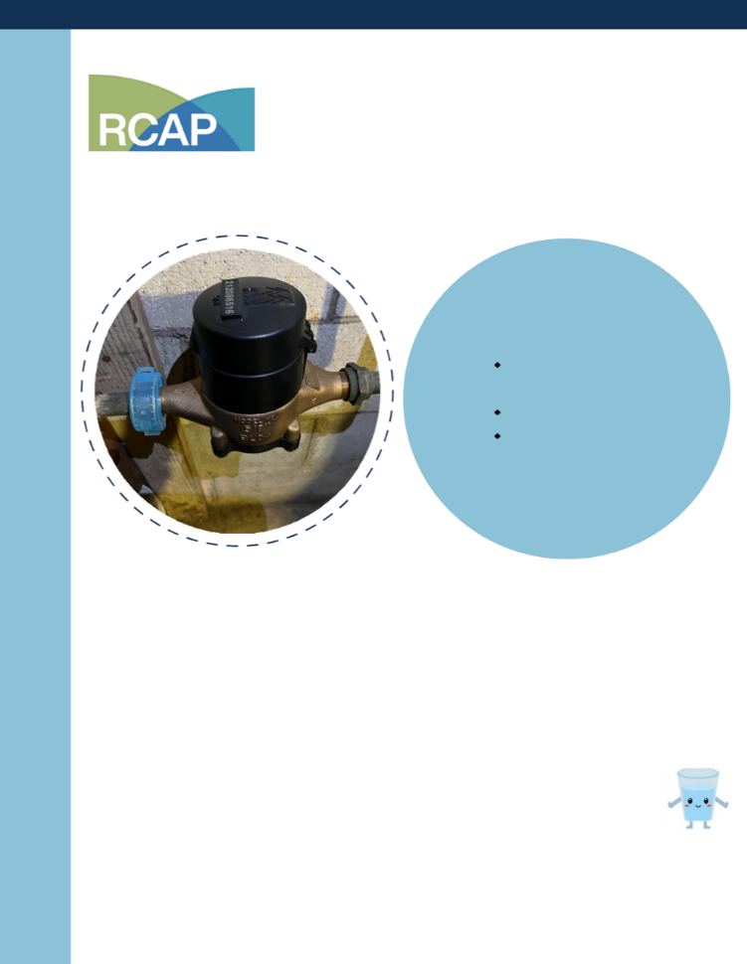water meter

Materials & Tips

* Copper looks like a penny
* Galvanized is magnetic
* Lead scratches shiny silver
* Plastic may be blue or black

**Know your material? Complete and submit the online survey for (community name) by scanning the QR code below. Your help is appreciated!**