Service Line Materials Identification

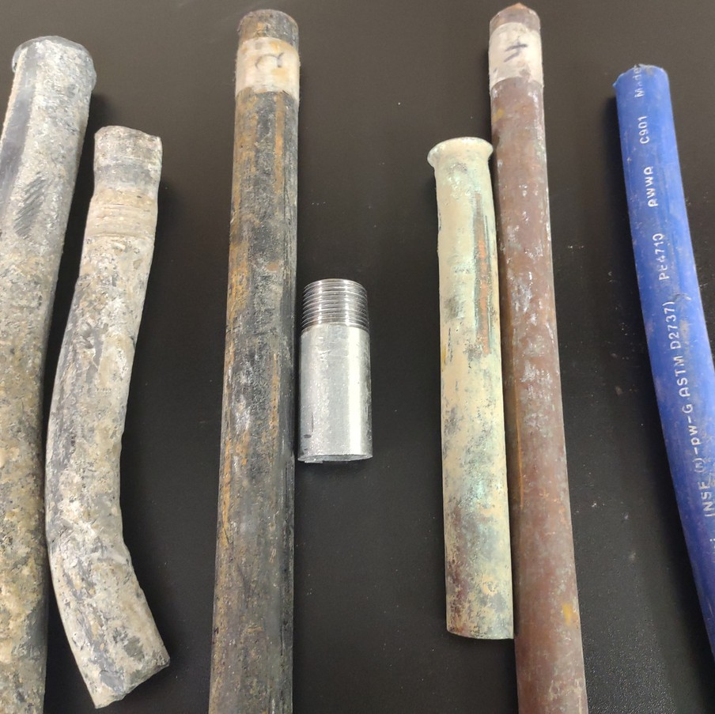

The US Environmental Protection Agency recently revised the lead and copper rule for community drinking water, requiring municipalities to gather and update water service line material information for all structures connected to the distribution system.

Participation from water customers is essential for completing this inventory. The Village of (Community Name) Water Department is asking for your help.

Please return this form with your name, address, and whether you have a lead, galvanized steel, copper, or plastic service line, and year home was built, to (Village Address)

If you have questions regarding this inventory, please

Email (Village Email Address)

How to Identify Service Line Material

1. **Locate the water meter.**

(Found inside the building.) Follow the water pipes in the basement or crawl space. Look near your water heater, furnace, or washer/dryer. The meter may also be under a kitchen or bathroom sink, inside the cabinet.

1. **Locate the service line.**

This is the pipe which comes up from the floor or out of the wall before the water meter. Water meters generally have an arrow printed on the body. The service line will be on the upstream side of the arrow. (See photo.)

1. **Identify the material and year home was built.**

Lead, Galvanized Steel, Copper, or Plastic

**Material Details for Identification**

* 1. **Lead**
     + Grey in color.
     + Non-magnetic
     + Soft metal, easy to mark.
     + Connections resemble a bulb shape.
  2. **Galvanized Steel**
     + Silver/grey in color.
     + Magnetic
     + May observe red/rusty areas.
  3. **Copper**
     + Similar color and shine of a Penny.
     + May have green and blue coloration.
     + Non-magnetic
  4. **Plastic**
     + Blue or black in color.
     + Lettering or stripes may be imprinted on the pipe.

Name

Address

Year House Built

Service Line Material

**Scan to Watch**

**“Lead Service Line Identification” Video**