Water Service Line Material Survey
[Water Department address goes here]

The City of [Community name] is required by the USEPA to inventory the water service line material for all customers as part of the recently released Lead and Copper Rule Revisions and Improvements. Please assist us by filling out the following questionnaire. It should take no more than 10 minutes to complete. Please return this form to the utility department at City Hall or mail it to the address at the top of this form. Your help in gathering this information is greatly appreciated.

To complete the survey, all you will need is a coin and a magnet.

Contact Information
Please write your contact information in the boxes below so that we can contact you with any questions on your survey response. * Indicates required input.

Full Name*: _______________________________________________________________
Phone Number: ___________________________________________________________
Email Address: _____________________________________________________________
Service Address*: __________________________________________________________

What’s a service line?
A water service line is the pipe that carries water from the city’s main to your meter, typically located in your house’s basement, crawlspace, or utility closet. If you need assistance in locating your service line, please contact the water department.
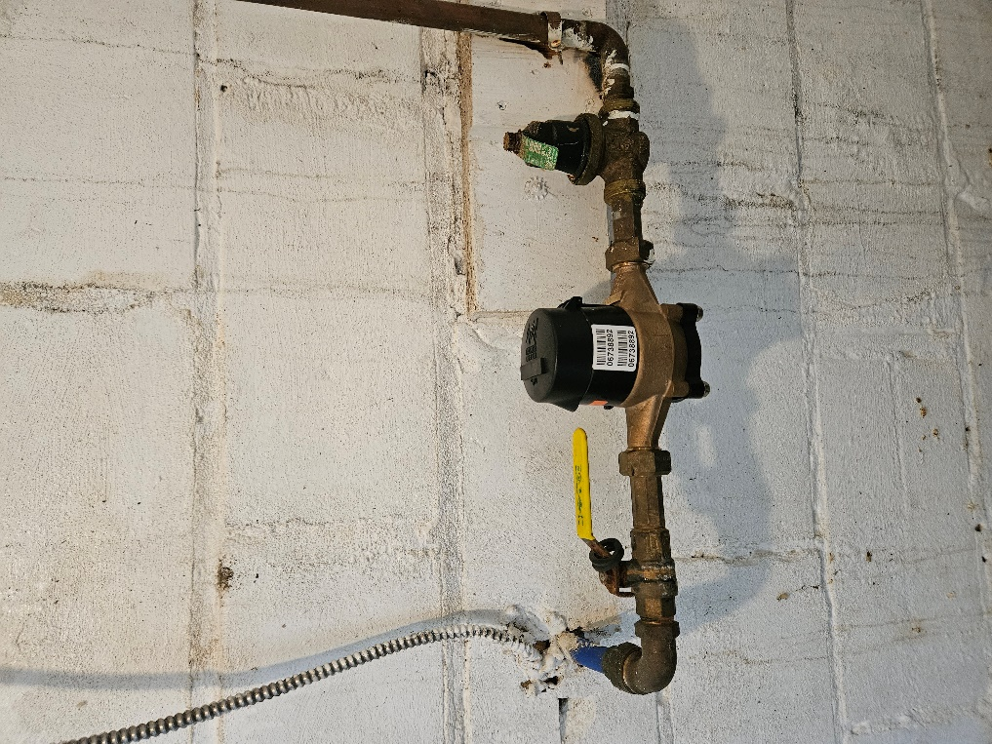
This is the interior plumbing, and beyond the water meter. This is not the piping to be reported.
This is the water service line, entering from the wall. The short length of pipe before any fittings is the area to observe and scratch. This may be only a couple of inches.

Pipe Material Questions
To the best of your ability, please answer the following questions.

Is your service line plastic? Plastic may be blue or black.

___ Yes, it’s made of Plastic ___No, it’s made of metal

If you checked “Yes, it’s made of plastic” then you have completed the survey. Please return this form to the utility department at City Hall or mail to the address at the top of this form.

Try scratching your pipe
If you checked “No, it’s made of metal” then please make a scratch on the pipe using a key or a coin near the point where it enters your house through the wall. Lightly scratch to remove paint, rust, and tarnish.
After making the scratch, can you determine the color beneath it?

___Orange like a copper penny (may have blue/green tarnish) ___Silver or gray ___Unsure

If you checked “Orange like a copper penny”, you have completed the survey. You have a copper service line. Please return this form to the utility department at City Hall or mail to the address at the top of this form.

If you checked “Unsure,” then you have completed the survey. Please contact the [Community name] Water Department to schedule a check with field assistance.

If you checked “Silver or gray,” then put the magnet close to the pipe.

Does a magnet stick to the pipe?
___Yes ___No

If you checked “Yes”, then your water service line is likely constructed of galvanized steel. Please return this form to the [Community name] Water Department.

If you checked “No” then you may have lead pipes. Please return this form to the utility department at City Hall or mail to the address at the top of this form.

You may also complete this survey online! Just scan the QR code below.

Optional Insert Online Survey QR code here. RCAP uses Survey123

The City of [Community name] would like to thank you for your assistance in completing this survey.

