# Dear (Community Name) Water Customer,

The water department team will be working in the community to inventory water service Lines. This inspection will require access to your water meter (most likely located in your basement) and will only last about 5-10 minutes. To make the process simple and easy, please locate your water meter within your home, and clear a path to it if necessary. These inspections will help the community maintain compliance with state lead mapping requirements. Not every home in the community will be inspected. This notification is being sent to target areas for inspection. The information we collect can be used to apply for grant funding to replace water service lines. We will be going door-to-door to schedule an appointment with you, and you are encouraged to fill out the attached scheduling sheet and return it in the pre-addressed and stamped envelope. Participation is voluntary and you can use the self-check provided to make an educated guess as to what type of service line you have.

# Thank you,

*Village of (Community Name)*

# Frequently Asked Questions

## Q – What is the purpose of this inspection project?

A - We are here to help your community create an inventory of service line information. We will use this information to update existing mapping and assess what is needed for future replacement projects. This information may be used to apply for grant funding for service line replacement. Some homeowners may qualify for service line replacement at no cost.

## Q - What are service lines?

A – Service lines connect your home to the main waterline in your neighborhood. Main lines move water to you from the water treatment plant. The service line is owned and maintained by the public water system up to the curb stop valve (the shutoff valve often found in front yards). The remainder of the service line is private property, as is interior plumbing.

## Q – What are lead service lines?

A - Lead service lines are water pipes that are made of lead. These were very common in the early 1900’s because lead was cheaper to manufacture and more malleable than other materials. Lead pipes were banned from use in 1986, but many of these pipes are still in service today.

## Q – What happens if I have a lead service line?

A – Lead pipe is obsolete and carries potential for health hazards. Not all lead service lines pose immediate health hazards, but all lead pipes carry potential for negative health effects. Removal of privately owned lead piping is highly recommended.

## Q – Does this inspection have a cost?

A – No, this is at no cost to you as home or business owner. This project has been fully funded by (funding source) funding.

## Q – How long does this inspection take? What does it entail?

A – This inspection usually takes about five to ten minutes. It includes a scratch test to identify the materials used. Common service line materials include copper, galvanized steel, plastic, and lead.

## Q – Am I required to complete this inspection by a certain date?

A – Participation is voluntary and may help in acquiring future grant funding for infrastructure improvements. All inspections will be completed by the end of (date of completion)

***Have more questions? Contact your Water Department.***

*(Community Name) Water Department – (Water department number or email address)*

# Scheduling Page

Village water department inspection crews will go door-to-door to schedule appointments and carry out inspections. Scheduling an appointment in advance will ensure timely completion of the project. Please schedule an appointment by contacting our inspection crew at:

(Water Department Employee) : (E-mail address)

Please include your name, address, and contact information so we can schedule a convenient time to complete the fast and easy inspection.

Or return this completed form using the pre-addressed and stamped envelope.

-

Full Name: **____________________________________________________________________**

Address: **______________________________________________________________________**

Cell phone: **____________________________________________________________________**

E-mail: **________________________________________________________________________**

Please select what time of day may work for you better. We will follow up to finalize this appointment.

|  |  |  |  |
| --- | --- | --- | --- |
|  | Morning | Afternoon | Evening |
| Monday | ☐ | ☐ | ☐ |
| Tuesday | ☐ | ☐ | ☐ |
| Wednesday | ☐ | ☐ | ☐ |
| Thursday | ☐ | ☐ | ☐ |
| Friday | ☐ | ☐ | ☐ |
| Saturday | ☐ | ☐ | ☐ |

An inspection is done by examining the water pipe and the water meter which is in the

basements of most homes. The entire process may last for about 5 – 10 minutes. Please ensure that your water meter is accessible. Thank you.

# Water Service Line Self Survey

By following a quick and easy guide, you can identify what material your service line is made of…

Listed below are the materials you will need to perform a “scratch test” on your service line.

* A key, penny, or screwdriver
* A magnet

1. 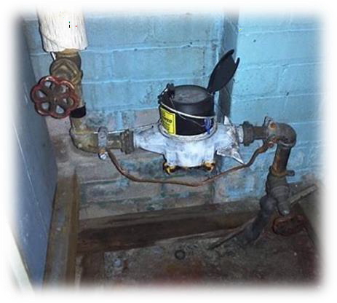First, you will need to locate your water meter, usually found in your basement. As seen to the right, your service line will feed into this. This is where you will perform the scratch test.
2. Next, you will use a key, coin, or screwdriver to scratch the pipe leading from the wall or floor of your home into the water meter.
3. 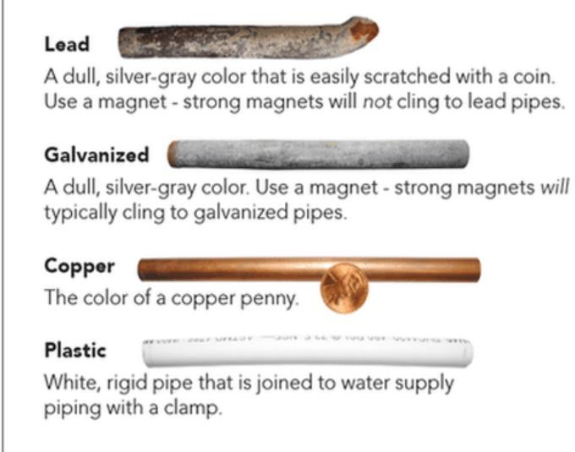As shown below, the most common materials are either copper, galvanized iron, plastic, or lead.

*Important things to look for when performing the scratch test is a shiny silver appearance likely indicating lead as the material. Lead is a soft material, so another indicator is it will easily indent with a coin. As mentioned in the picture to the left, lead is non-magnetic, so using the magnet can help determine the material as well.*

***My service line appears to be:***

* **Lead ☐ Galvanized ☐ Copper ☐ Plastic ☐Other (specify)**

It helps us to have residents perform a short self-survey of their service lines. Doing so can ensure we assist as many residents as possible. We want to personally thank you for taking the time to respond to this.

Please follow the instructions on the back of this guide to send your results to our office so that we can follow up with you.